**Experiment No:** 03

**Experiment Name:** Write HTML Program for Tables.

**Theory:** A Table is an arrangement of rows and columns. Anyone can create a table by knowing the basics

of HTML. A table is defined by using the <table> tag in HTML.

**Steps to create an HTML Table:**

❖ Start creating tables using the <table> tag and use </table> at the end.

❖ Then provide a name for this table with the <caption></caption> tag.

❖ Inside the starting and ending points define the table head and table body using

<thead></thead> and <tbody></tbody> tag.

❖ Inside <thead> and <tbody> tag define the table row using <tr> tags.

❖ Inside <thead>: define columns inside each row (<tr>) using <th> tags.

❖ Inside <tbody>: define columns inside each row (<tr>) using <td> tags.

**Lab Task-1:** Created my class routine using HTML Table tags:

**Source code:**

<!DOCTYPE html>

<html>

<table border="3" cellspacing="3"cellpadding="3">

<thead>

<tr>

<th><b>Time</b><br>

<p>/</p>

<p>Day</b></th>

<th><b>1</b><br><b>08:20-09:10</b></th>

<th><b>2</b><br><b>09:10-10:00</b></th>

<th><b>3</b><br><b>10:00-10.50</b></th>

<th><b>4</b><br><b>10:50-11:40</b></th>

<th><b>5</b><br><b>11:40-12:30</b></th>

<th><b>6</b><br><b>12:30-01:20</b></th>

</tr>

</thead>

<tbody>

<tr>

<th>Saturday</th>

<td>CCE-1209<br>ZT<br>R:304</td>

<td>URED-1209<br>DMIH<br>R:304</td>

<td>PHY-1201<br>NME<br>R:304</td>

<td>MATH-1201<br>AH<br>R:304</td>

<td>MATH-1201<br>AH<br>R:304</td>

<td>CCE-1207<br>MJH<br>R:304</td>

</tr>

<tr>

<th rowspan="2">Sunday</th>

<td colspan="3">CCE-1210 (Group-A)<br>MHK<br><small>Electronic Lab(FSE)</small></td>

<td rowspan="2">MATH-1201<br>AH<br>R:304</td>

<td rowspan="2">PHY-1201<br>NME<br>R:304</td>

<td rowspan="2">PHY-1201<br>NME<br>R:304</td>

</tr>

<tr>

    <td colspan="3">CCE-1206(Group-B)<br>MNH<br><small>Programming Lab</small></td>

</tr>

<tr>

<th rowspan="2">Monday</th>

<td colspan="3">PHY-1202(Group-A)<br>NME

<br><small>Physics Lab(CSE,FAZ)</small></td>

    <td colspan="3">PHY-1202(Group-B)<br>NME

<br><small>Physics Lab(CSE,FAZ)</small></td>

</tr>

<tr>

    <td colspan="3">CCE-1210(Group-B)<br>MHK<br><small>Electronic Lab(FSE)</small></td>

<td colspan="3">CCE-1208(Group-A)<br>MJH<br><small>Basic Computer & Simulation Lab</small></td>

</tr>

<tr>

<th>Tuesday</th>

<td>MDP-2</td>

<td>URED-1201<br>DMIH<br>R:304</td>

<td>CCE-1207<br>MJH<br>R:304</td>

<td></td>

<td></td>

<td></td>

</tr>

</tr>

<tr>

<th rowspan="2">Wednesday</th>

<td colspan="3">CCE-1208(Group-B)<br>MJH<br><small>Basic Computer Simulation Lab</small></td>

<td rowspan="2">CCE-1207<br>MJH<br>R:304</td>

<td rowspan="2">CCE-1209<br>ZT<br>R:304</td>

<td rowspan="2">CCE-1209<br>ZT<br>R:304</td>

</tr>

<tr>

<td colspan="3">CCE-1206(Group-A)<br>MNH<br><small>Programming Lab</small></td>

</tr>

</tbody>

</html>

**Output(compilation,debugging & testing):**

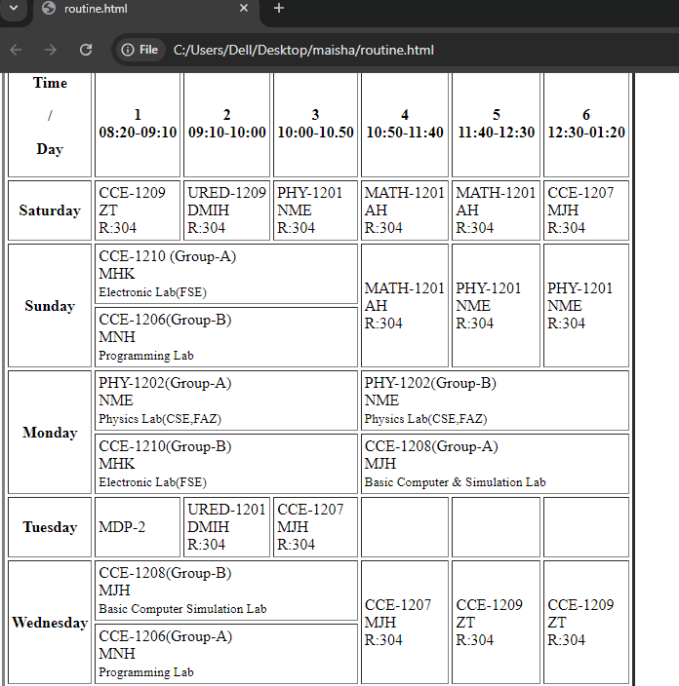

**Lab Task-2:** Created a table similar to the table given below:

**Source Code:**

<!DOCTYPE html>

<html lang="en">

<head>

<meta charset="UTF-8">

<meta name="viewport" content="width=device-width, initial-scale=1.0">

<title>Table</title>

</head>

<body>

<table border="5" cellspacing="3"cellpading="3">

<thead>

<tr>

<th rowspan="2"> Heading</th>

<th colspan="1"> Students</th>

<th colspan="3"> Details</th>

</tr>

<tr>

<th>Id</th>

<th>Name</th>

<th>Department</th>

<th>Rol Number</th>

</tr>

</thead>

</thead>

<tr>

<th rowspan="4">Students List</th>

<td>1</td>

<td>Victor</td>

<td>Computer Science</td>

<td>12345</td>

</tr>

<tr>

<td>2</td>

<td>Williams</td>

<td>Electronics</td>

<td>23456</td>

</tr>

<tr>

<td>3</td>

<td>Harry</td>

<td>Electrical</td>

<td>34567</td>

</tr>

<tr>

<td>4</td>

<td>Rick</td>

<td>Civil</td>

<td>45678</td>

</tr>

</tbody>

</table>

</body>

</html>

**Output(compilation,debugging & testing):**

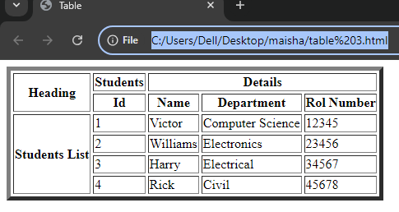

**Experiment No:** 04

**Experiment Name:** Introduction to HTML Lists.

**Theory:** HTML Lists are used to specify lists of information. All lists may contain one or more list elements. There are three basic types of HTML lists:

1. Ordered List (ol).

2. Unordered List or Bulleted List (ul).

3. Description List or Definition List (dl).

**1.HTML Ordered list(ol):**

❖ In HTML, all the list items in an ordered list are marked with numbers by default instead of bullets.

❖ An HTML-ordered list starts with the <ol> tag and ends with the </ol> tag.

❖ And, inside the <ol> </ol> tags, we have to define the lists using <li></li> tags.

❖ Inside the <li></li> tags we have to define the list contents.

**Lab Task-1:**Created HTML lists similar to the following lists:

**Source Code:**

<!DOCTYPE html>

<html lang="en">

<head>

<meta charset="UTF-8">

<meta name="viewport" content="width=device-width, initial-scale=1.0">

<title>HTML lists</title>

</head>

<body>

<ol type="A">

<h2>1.Cart Order:</h2>

<dd><li>Book</li></dd>

<dd><li>Pen</li></dd>

<dd><li>T-Shirts</li></dd>

<dd><li>Jeans</li></dd>

</ol>

<ol type="a">

<h2>2.Vehicles List:</h2>

<dd><li>Cycle</li></dd>

<dd><li>Car</li></dd>

<dd><li>Bus</li></dd>

<dd><li>Taxi</li></dd>

</ol>

<ul>

<h2>3.List of Programming Languages:</h2>

<dd><li>C</li></dd>

<dd><li>C++</li></dd>

<dd><li>Java</li></dd>

<dd><li>JavaScript</li></dd>

<dd><li>Rust</li></dd>

</ul>

<ul>

<h2>4.List of Database:</h2>

<dd><li>MySQL</li></dd>

<dd><li>MongoDB</li></dd>

<dd><li>PostgreSQL</li></dd>

<dd><li>GraphQL</li></dd>

</ul>

</body>

</html>

**Output(compilation,debugging & testing):**

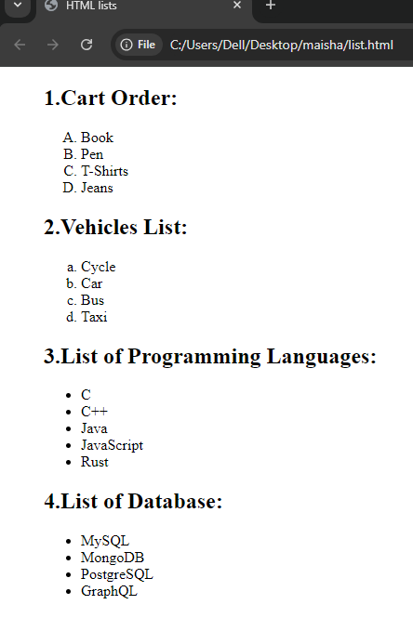

**Lab Task-2:**Described the information, and qualities about the listed person with a title using HTML definition list:

**Source Code:**

<!DOCTYPE html>

<html lang="en">

  <head>

    <meta charset="UTF-8" />

    <meta name="viewport" content="width=device-width, initial-scale=1.0" />

    <title>Document</title>

  </head>

<body>

    <h1>

      <font color="navy blue">Chairman & Co-ordinator</font>

    </h3>

      <h2>

        <font color="navy" blue>Professor & Chairman</font>

  </h2>

      <h3>

        <font color="green">Prof.Md.Razu Ahmed</font>

      </h3>

      <dd><li>PhD (Pursuing CSE-CU);</li></dd>

      <dd><li>

        M.Engg. Telecommunication Engineering, Asian Institute of

        Technology(AIT),Thailand:

      </li></dd>

      <dd><li>B.Sc. Engg. in Electronic and Communication Engineering, KU</li></dd>

      <dd><li>Professor of Computer ,Telecommunication</li></dd>

      <dd><li>Mobile: 01874543665</li></dd>

      <dd><li>razu17@yahoo.com, razu17@iiuc.ac.bd</li></dd>

      <h2>

        <font color="navy" blue>Assistant Professors</font>

      </h2>

      <h3>

        <font color="green">Dr.Mohammed Saifuddin</font>

      </h3>

      <dd><li>Postdoc, University of Malaya, Malaysia</li></dd>

      <dd><li>PhD, University of Malaya, Malaysia</li></dd>

      <dd><li>MSc, University of Malaya, Malaysia</li></dd>

      <dd><li>MSc, University of Chittagong, Bangladesh</li></dd>

      <dd><li>BSc, CU, Bangladesh</li></dd>

      <dd><li>Assistant Professor of Chemistry and Bioengineering</li></dd>

      <dd><li>Mobile: 01945767849</li></dd>

      <dd><li>saifuddin.cu.um@gmail.com, saifuddin@iiuc.ac.bd</li></dd>

      <h3>

        <font color="green">Amanul Hoque</font>

      </h3>

      <dd><li>Assistant Professor of Mathematics</li></dd>

      <dd><li>Mobile: 01818673657</li></dd>

      <dd><li>amanul07maths@gmail.com, amanulcox78@iiuc.ac.bd</li></dd>

      <h3>

        <font color="green">Md Jiabul Hoque</font>

      </h3>

      <dd><li>PhD (Pursuing, CUET)</li></dd>

      <dd>M.Sc. in CSE, University of Greenwich, London, United Kingdom</li></dd>

      <dd><li>B.Sc. in CSE, CUET, Bangladesh</li></dd>

      <dd><li>Assistant Professor of CSE</li></dd>

      <dd><li>Mobile: 01989685996</li></dd>

      <dd><li>jia99cse@yahoo.com, jiabul.hoque@iiuc.ac.bd</li></dd>

      <h2>

        <font color="navy" blue>Lecturer's</font>

      </h2>

      <h3>

        <font color="green">Areez Hafiz Md Zahid</font>

      </h3>

      <dd><li>M.Phil. in Biotechnology</li></dd>

      <dd><li>Lecturer in Biotechnology</li></dd>

      <dd><li>Mobile: 01977723403</li></dd>

      <dd><li>michelle_wellessely@yahoo.com, areezhafiz@iiuc.ac.bd</li></dd>

      <h3>

        <font color="green">Mohammad Nadib Hasan</font>

      </h3>

      <dd><li>

        B.E. in COMPUTER ENGINEERING, Gujarat Technological University [GTU],

        India.

      </li></dd>

      <dd><li>Lecturer in Computer Science</li></dd>

      <dd><li>Mobile: 01521483958</li></dd>

      <dd><li>nadibhasan.gtu.in@gmail.com, nadibhasan@iiuc.ac.bd</li></dd>

      <h3>

        <font color="green">Md.Humayun Kabir</font>

      </h3>

      <dd><li>B. Sc. in ETE, [IIUC].</li></dd>

      <dd><li>Pursuing M.Sc. in ETE, [CUET].</li></dd>

      <dd><li>Lecturer</li></dd>

      <dd><li>Mobile: 01515286984</li></dd>

      <dd><li>mhk.cce.iiuc@gmail.com, mkabir@iiuc.ac.bd</li></dd>

      <h3>

        <font color="green">Hassan Jaki</font>

      </h3>

      <dd><li>B.Sc. in Electronic and Telecommunication Engineering (IIUC)</li></dd>

      <dd><li>Lecturer</li></dd>

      <dd><li>Mobile: 01950853985</li></dd>

      <dd><li>hassanjaki11@gmail.com, hassanjaki@iiuc.ac.bd</li></dd>

      <h3>

        <font color="green">Zarin Tanzim</font>

      </h3>

      <dd><li>Lecturer</li></dd>

      <dd><li>Mobile: 01850925671</li></dd>

      <dd><li>zarintanzim11@gmail.com, zarintanzim11@iiuc.ac.bd</li></dd>

    </dl>

  </body>

</html>

**Output(compilation,debugging & testing):**

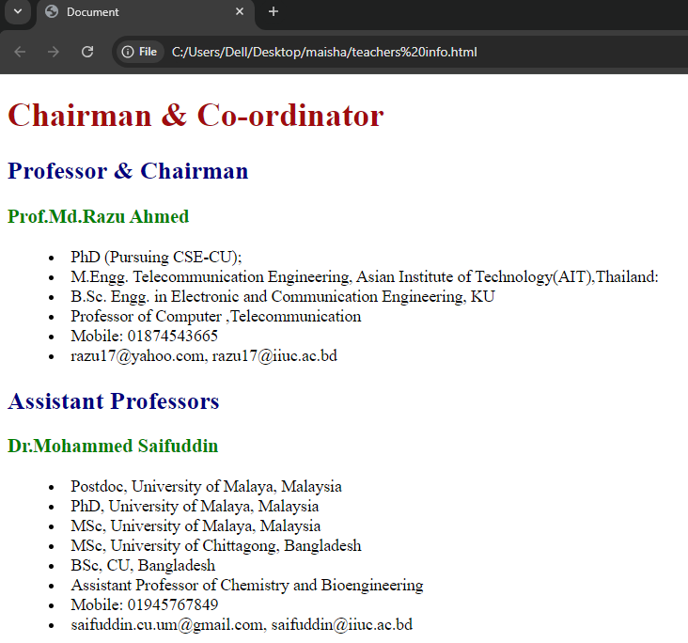

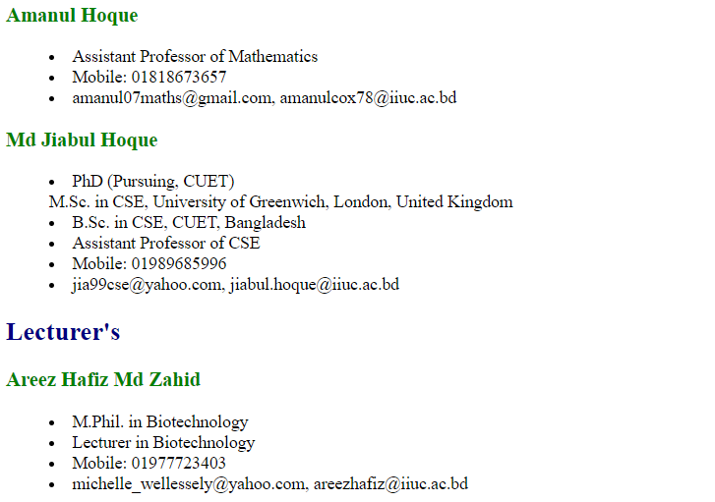

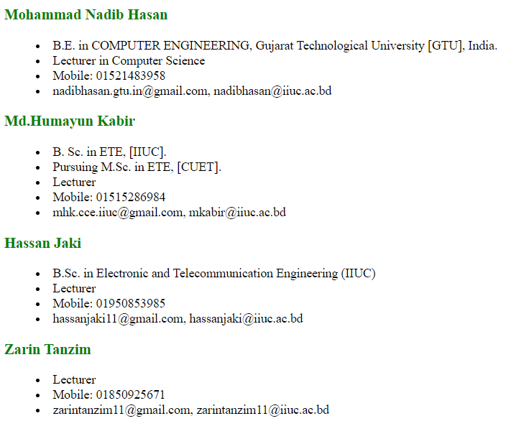

**Discussion:** From this lab sessional,I got to learn how to write HTML program for tables and lists.So first of all,I created my class routine using HTML table tags and created another similar table in the 3rd experiment.For this I used <table>,<thread>,<tbody>,<tr>,<td> etc tags.Then I created HTML lists and make another lists about my professors and lecturers information and qualities in the 4th experiment.For this I used definition list tags like <dt>, <dd>,<li> etc.By using those tags I completed my lab task successfully.